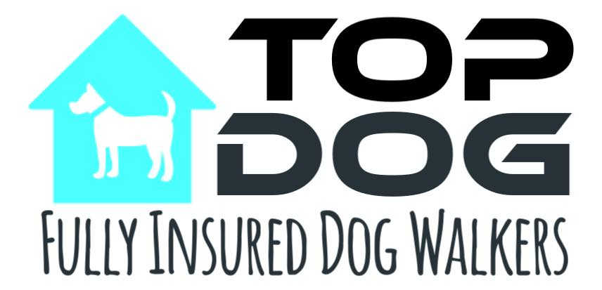
Terms and Conditions
General
1. All clients will be deemed to have accepted Top Dog’s terms and conditions (as laid out here) on signature of the contract.
2. Top Dog will not confirm any booking until a consultation has been carried out with the client and the contract, with full details of client requirements, has been signed by the client.
3. Full payment for services (agreed either at time of booking or subsequently) is to be made within 7 days of receipt of invoice or, by the date specified on the invoice (for dog walking clients) via cash, or bank transfer.
4. The client must provide all items necessary for pets to be adequately cared for in the client's absence. (i.e., food, medication, leads, tags, collars, cat litter etc). Should pets require any additional supplies whilst in the care of Top Dog, these will be purchased and added to the bill.
5. If it is necessary for keys to be picked up or dropped off in order to complete an assignment charges will be applied for each trip.
6. The client must provide Top Dog with the name and contact number of someone capable of making a decision relating to the pet(s) in an emergency. If the contact is not available Top Dog reserves the right to consult with a veterinary surgeon and then make a decision which is in the best interests of the animal.
7. The client is responsible for any veterinary bills, no matter how they are incurred, whilst pets are in the care of Top Dog.
8. Top Dog must be alerted to any behavioural problems with their pets at the time of booking. Failure to do so may result in additional charges or cancellation of any future contract.
9. Although Top Dog holds Public Liability insurance, wherever possible pets should be insured by the client.
10. Top Dog will care for your animal as you would, and whilst we will make every effort to ensure your pet is well looked after in your absence, Top Dog cannot be held liable for any loss, injury or death to a pet either inside or outside of the home whilst in our care.
Dog Walking
1. All dogs being exercised must be fully vaccinated and on a regular flea and worm control regime.
2. All dogs being walked will undergo a trial period to ensure that they are adequately trained and socialised.
3. Top Dog reserves the right to cancel the contract at any time & with immediate effect if the dog does not respond well to the walker and/or other dogs.
4. All dogs will be exercised on a lead unless prior agreement has been reached with Top Dog and a disclaimer form has been signed.
5. The walker will apply personal judgment and cut short a walk if necessary because of extreme weather conditions (ie, heat, thunder storms) for the safety of both the dogs and the walker.
6. If dogs require a quick towelling off after walks towels must be provided and left by the front door.

Pet Feeding
1. Any cancellations must be made more than 48 hrs in advance or the full rate will be charged.
2. Top Dog will make adequate steps to ensure your home is safe and secure in your absence, however Top Dog cannot be held responsible for any burglaries or accidents caused by your pet(s).
3. The client must provide all items necessary for your pet to be adequately cared for in the clients absence.

